Appendix

Figure 1

DHA Absorption in Gastrointestinal Tract of Maternal Mice

Group | Concentration of DHA (μg/mg)
 | Stomach | Duodenum | Jejunum | Ileum | Colon
Normal FO | 1.93 ± 0.65 | 1.22 ± 0.80 | 1.50 ± 0.37 | 1.01 ± 0.39 | 1.34 ± 0.51
Nano FO | 1.25 ± 0.44 | 2.52 ± 0.73 * | 2.14 ± 0.59 * | 0.91 ± 0.34 | 0.79 ± 0.38
(* significant difference)

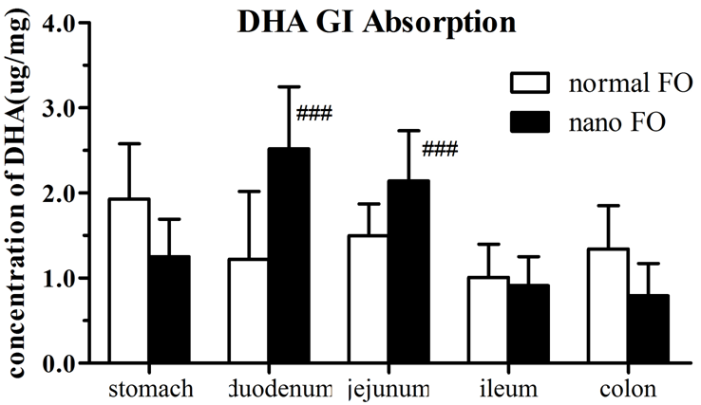
Stomach duodenum jejunum ileum colon

Figure 2

DHA Biodistribution in Maternal Tissues

Group | Concentration of DHA (mg/g)
 | Brain | Liver | Serum
Normal FO | 11.64 ± 1.75 | 4.46 ± 3.04 | 0.39 ± 0.43
Nano FO | 14.40 ± 0.60* | 6.09 ± 2.28 | 0.44 ± 0.42
(* significant difference)
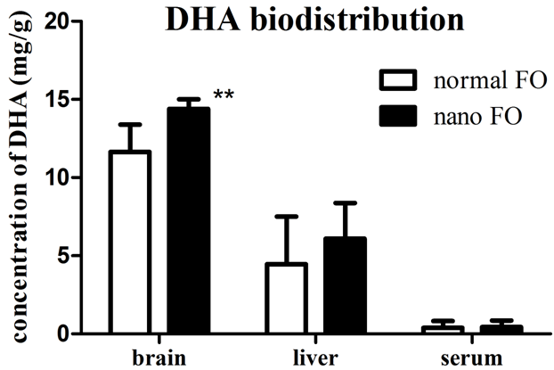
Figure 3

Novel Object Recognition

Group | Time (second)
 | Familiar object | Novel object
Control | 10.83 ± 1.61 | 9.17 ± 1.61
Zein | 9.78 ± 1.06 | 10.22 ± 1.06
Normal FO – Low | 10.67 ± 1.58 | 9.33 ± 1.58
Normal FO – High | 7.44 ± 1.37 * | 12.56 ± 1.37 *
Nano FO – Low | 8.88 ± 2.26 * | 11.12 ± 2.26 *
Nano FO – High | 7.34 ± 1.76 * | 12.66 ± 1.76 *
(* significant difference)

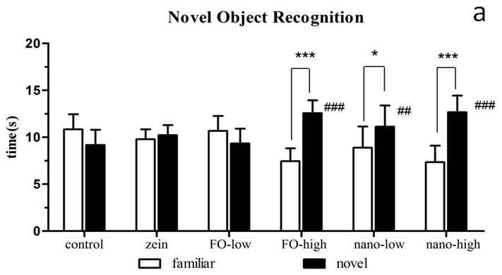

Figure 4

Brain-Derived Neurotrophic Factor (BDNF) in Offspring

Group | Concentration of BDNF (pg/mg)
 | Cortex | Hippocampus
Control | 5593.25 ± 334.01 | 5800.32 ± 1078.74
Zein | 6023.66 ± 1027.70 | 5795.75 ± 662.36
Normal FO – Low | 6472.64 ± 611.28 | 5309.60 ± 986.22
Normal FO – High | 4934.02 ± 1369.51 | 6088.34 ± 951.90
Nano FO – Low | 5644.65 ± 626.46 | 6165.31 ± 428.70
Nano FO – High | 6162.00 ± 255.30 | 7917.77 ± 629.92*
(* significant difference)

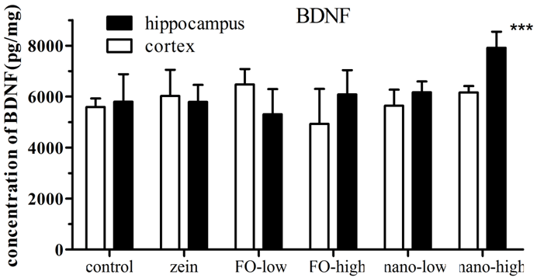
nano-high

Figure 5

Y-maze Test

Group | Time (second)
 | Start arm | Familiar arm | Novel arm
Control | 129.72 ± 26.80 | 81.87 ± 23.21 | 88.13 ± 10.25
Zein | 116.40 ± 16.71 | 90.15 ± 18.47 | 92.97 ± 12.25
Normal FO – Low | 118.52 ± 15.80 | 85.89 ± 21.89 | 95.17 ± 13.28
Normal FO – High | 126.03 ± 22.45 | 78.36 ± 19.31 | 95.36 ± 15.09
Nano FO – Low | 120.38 ± 20.27 | 81.75 ± 17.90 | 96.51 ± 16.31
Nano FO – High | 130.72 ± 21.22 | 74.18 ± 23.67 * | 95.10 ± 24.87 *
(*significant difference)

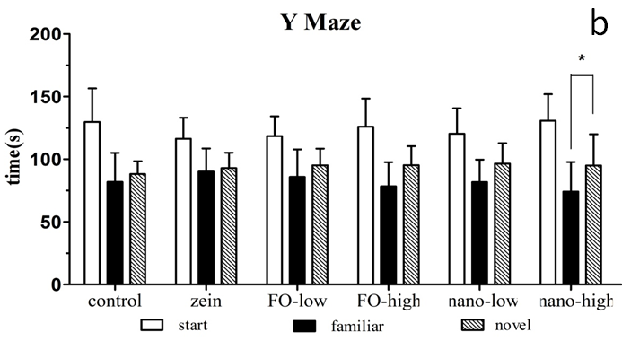
nano-high

The time that the mice exploring the three different arms (the start, familiar and novel arms) of a Y-maze were recorded. Longer time spent in exploring novel arm compared to familiar arm would indicate better spatial learning and memory abilities.

