Health Future Challenge 2023
RESEARCH TEAM APPLICATION FORM

About the Challenge | https://polyu.hk/YpXEE
Health Future Challenge 2023 is a start-up ideation competition for students, researchers, alumni and industrialists to team up and come up with health-tech ideas and business model for the future. The competition aims to:
- source impactful innovations for the future
- catalyse inter-disciplinary team formation and business and technology integration through the entrepreneurship competition process
- advancing PolyU domain expertise through translational research and start-ups

Competition Structure
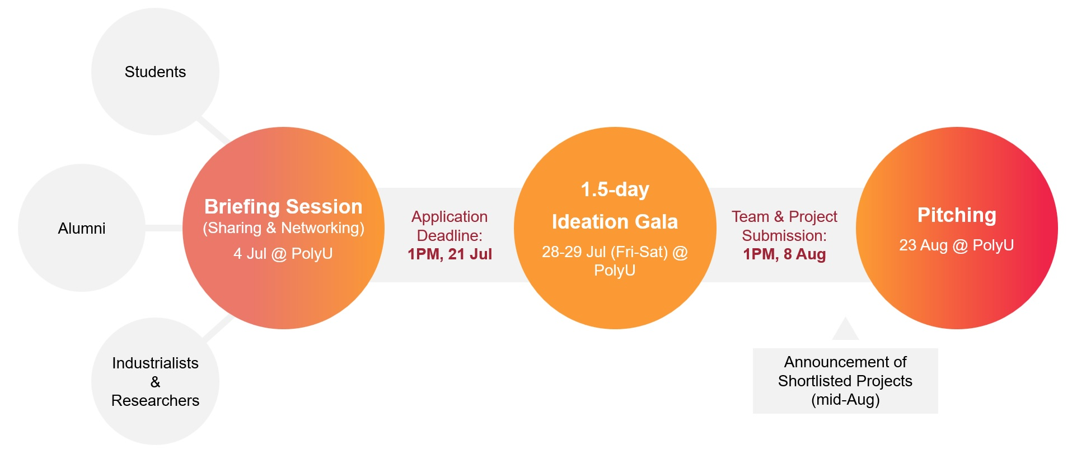

Call for FHSS, ABCT and BME Research Teams | by 21 Jul 2023
To encourage formation of inter-disciplinary teams to translate the research outcomes into market-ready solutions through the Challenge, FHSS, ABCT and BME will provide a Translational Research Grant of HK$500,000 (for FHSS research team), HK$200,000 (for ABCT research team) or HK$200,000 (for BME research team) with follow-up supports for the winning research team(s), on top of:
- Cash prize ~HK$11,000
- Admission to PolyU Student Entrepreneurial Proof-of-Concept (POC) Funding Scheme for up to HK$20,000 scholarship and pre-incubation supports

If you are interested in the Challenge, please complete this application form and Knowledge Transfer and Entrepreneurship Office (KTEO) will follow up with the research teams for the Challenge details.

Enquiry (KTEO): +852 3400-2624/ 2651; cs-karina.chan@polyu.edu.hk
Part A: TEAM DETAILS (team size: max. 5)
*You are encouraged to meet and add in new members for this Challenge during the briefing session and Ideation Gala. So you may not need to use up all 5 seats at this moment.
Main contact person
Full Name in English:  (Mr/ Miss/ Mrs/ Dr) | Associated with the Faculty/ Department (MPhil student/ PhD student/ Research Assistant/ Supervisor/ etc.):
Full Name in Chinese
(if applicable)
Email Address: | Faculty & Department:
Phone No.: | Highest Academic Qualification:
Student ID No.:  (if applicable) | Programme:  (if applicable)

2nd Team member
Full Name in English:  (Mr/ Miss/ Mrs/ Dr) | Associated with the Faculty/ Department (MPhil student/ PhD student/ Research Assistant/ Supervisor/ etc.):
Full Name in Chinese
(if applicable)
Email Address: | Faculty & Department:
Phone No.: | Highest Academic Qualification:
Student ID No.:  (if applicable) | Programme:  (if applicable)

3rd Team member
Full Name in English:  (Mr/ Miss/ Mrs/ Dr) | Associated with the Faculty/ Department (MPhil student/ PhD student/ Research Assistant/ Supervisor/ etc.):
Full Name in Chinese
(if applicable)
Email Address: | Faculty & Department:
Phone No.: | Highest Academic Qualification:
Student ID No.:  (if applicable) | Programme:  (if applicable)

4th Team member
Full Name in English:  (Mr/ Miss/ Mrs/ Dr) | Associated with the Faculty/ Department (MPhil student/ PhD student/ Research Assistant/ Supervisor/ etc.):
Full Name in Chinese
(if applicable)
Email Address: | Faculty & Department:
Phone No.: | Highest Academic Qualification:
Student ID No.:  (if applicable) | Programme:  (if applicable)
5th Team member
Full Name in English:  (Mr/ Miss/ Mrs/ Dr) | Associated with the Faculty/ Department (MPhil student/ PhD student/ Research Assistant/ Supervisor/ etc.):
Full Name in Chinese
(if applicable)
Email Address: | Faculty & Department:
Phone No.: | Highest Academic Qualification:
Student ID No.:  (if applicable) | Programme:  (if applicable)

PART B: RESEARCH PROJECT DETAILS *please tick as appropriate

Project Name:
Project Type*: | ☐ Research Project  ☐ Others: ___________________________________
Principal Investigator (PI):
Project Description
in English
(around 100 words)
Problem to solve
Final Deliverable
Target Customer
Project photos
(if any)
Project video link
(if any)

PART C: IMPORTANT DATES

Events | Date & Time & Venue | Reply  *please tick as appropriate
Briefing Session | Networking | 4 Jul 2023 (Tue)  5:30 – 7:30PM  TU201, PolyU | ☐ Our team will join the briefing session.  ☐ Our team will NOT join the briefing session.
Ideation Gala | Team Formation | Workshop | 28-29 Jul 2023 (Fri-Sat)  Day 1: 6 - 9PM  Day 2: 10:30AM - 6PM  N101 - N103, PolyU | ☐ Our team will join the Ideation Gala and pitching.  ☐ Our team have the access to PolyU campus.
Application Deadline | 8 Aug 2023 1PM (Tue)
Announcement of Shortlisted Projects | Mid Aug
Pitching | 23 Aug  PolyU

